**New Scoreboard UI Design Specification**

**Goal:** design new UI for RPM retail so that the customers can view a RPM Scoreboard dashboard with advanced filtering options, clear KPI visualizations, detailed KPI calculations, and actionable fix options

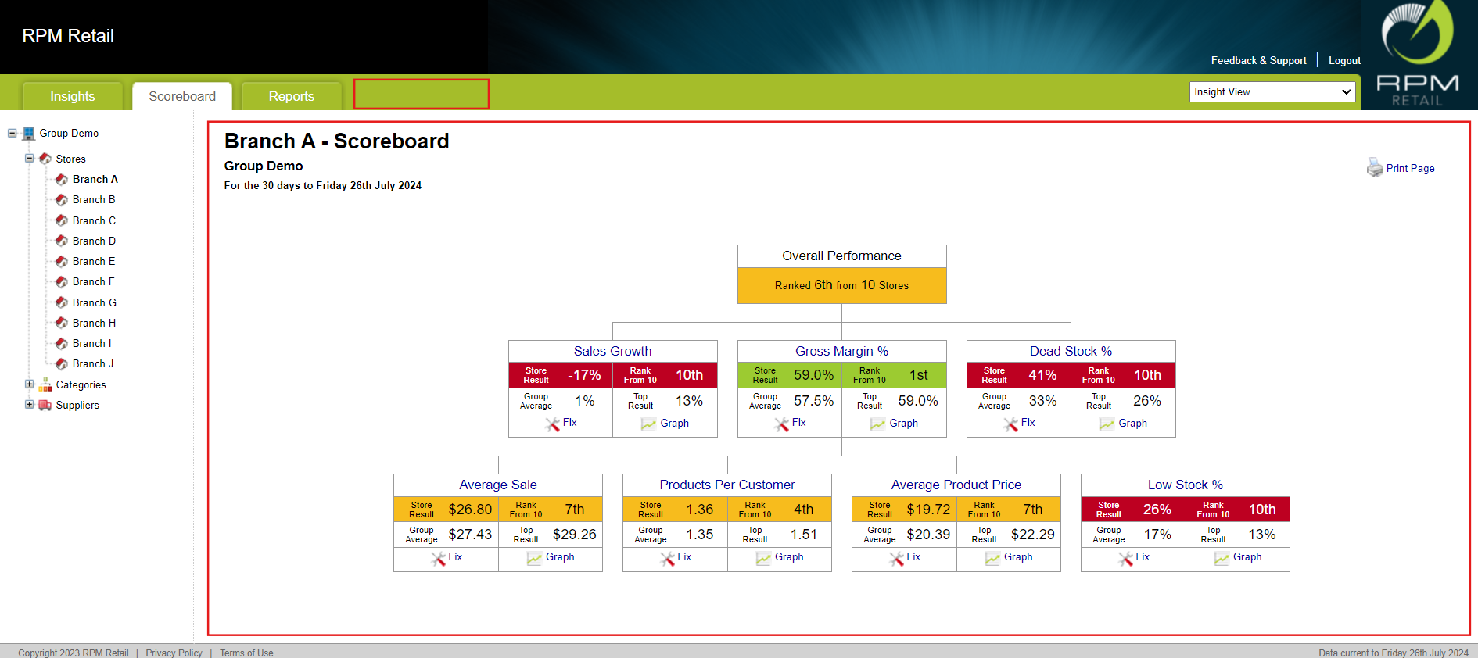

*(Outlined areas to implement the new design)*

**Notes:**

* The dashboard should dynamically update based on my selected filters to ensure users viewing the most current and relevant data.
* The visual indicators and actionable insights should help users make informed decisions and drive performance improvements.
* KPI calculation details and actionable fixes should be easily accessible to ensure clarity on performance metrics and improvement actions.

**Design Requirements:**

1. When log in, **Head Office Users** can see the group average performance. When I select a store from the side dropdown menu, I should see the selected store’s performance benchmarked against the Group average. (default all stores selected as the group)
2. Users can view the dashboard for a **set period**

* Last 30 Days [Default view]

1. Filtering

**Options:**

* Supplier(s)
* Category(s)

**Default for each Filter = ALL**

**Filters are Multiselect**

**Heading on Scoreboard updates to show “selected” parameters dynamically (no need to show 'ALL' if no filter is selected)**

**Example:**

*(Figma Design Example)*

* + - If ‘Store B’ is selected from the side navigation menu, along with ‘Supplier A’, ‘Supplier B’ and ‘Category A’, ‘Category B’, ‘Category C’ selected in the filter dropdown list in the filter section of scoreboard, the heading summary should be formatted as follows:
    - **Store B** - scoreboard | **Category:** A, B, C; **Supplier:** A, B

1. Design an “**Update**” button for users to reload the dashboard data based on selected filters. There also should be a "**Clear Filters**" button available if users wish to reset all filters and return to the default view.
2. KPIs to Compare Against:
   * 1. **Gross Margin %**
     2. **Sales Growth %**
     3. **Stock Turn**
     4. **Dead Stock %**
     5. **Low Stock %**
     6. **Out of Stock % (on hold)**
     7. **Customer Growth %**
     8. **Products Per Customer**
     9. **Average Sale**
     10. **Average Product Price**

**Functionality:** Each KPI heading should be hyperlinked. Clicking on a KPI heading should display a detailed explanation of how that KPI is calculated.

**The Value of the Measures pertaining to each KPI should be displayed too.**

Gross Margin $

Sales $

Stock on Hand $

Dead Stock $

Customers

1. **Actionable Fix Button Functionality Based on Selected Filters:**
   1. **Fix Button:** For KPIs Gross Margin %, Low Stock %, Dead Stock %, Products Per Customer, a “Fix” button should be available.
      1. The Fix will need to receive the “Filters” selected so that the subsequent screens info is filtered correctly
      2. **Functionality:** Clicking the “Fix” button should open a new window or modal with actionable suggestions. For example, if Gross Margin % is low:
         1. The window should display a table of categories where gross margin is lower than the group average, showing the difference.
         2. **Options for Action:** User should have the option to:
            1. **Drill Down:** Users should have the option to drill down into specific issues within the filtered context (e.g., click on a specific category within Store A to address individual product issues).
            2. **Select All:** Users can choose to apply fixes across all issues related to the selected filters. For example, if fixes for all categories within Store A are needed, users can select "Apply Fixes to All" categories within Store A.

**Default (All categories selected)**

**Deselect categories to fix the checked categories only**

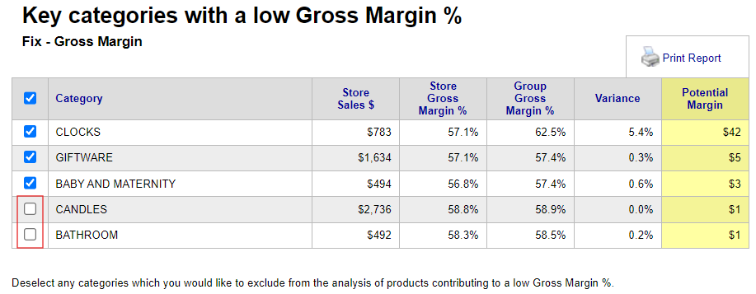

* 1. **Fix Wizard Operation:**
     1. **Initial Display:** When the user clicks the "Fix" button for a KPI, the fix wizard should open and immediately reflect the selected filters.
     2. **Example Scenario:** If the user is viewing fixes for a KPI with the following filters applied:
        1. Store: Store B
        2. Supplier: A, B
        3. Category: A, B, C

*(Figma Design Example)*

* + 1. The fix wizard should show only those fixes that are relevant to Store B, Supplier A, B, and Category A, B, C: Only issues related to Store B’s performance with Supplier A and B’s products in Category A, B, C.

1. **New Dashboard Features Summary:**
   1. **KPI Rankings:** The dashboard should display my store’s ranking against the group based on the 9 KPIs including the overall position ranking
   2. **Colour Coding:**
      1. Results better than the group average should be highlighted in Green.
      2. Results near the group average should be shown in Orange.
      3. Results significantly lower than the group average should be marked in Red.
   3. **Group Average Results:** I should see the group average results alongside my store’s results for each KPI to easily compare performance.
   4. **KPI Rankings:** Each KPI result should be accompanied by a ranking to show how my store compares to others.
   5. **Actionable Improvements:** The dashboard should offer a “Fix Button” to address KPIs that are below average.
   6. **Top KPI Performance:** The dashboard should also show the highest achieved results for each KPI to highlight peak performance.
   7. **User can adjust Filters and Dimensions and have the option to “Save” this view as their Default or Favourite Scoreboard(s) which will display when they log in.**
   8. **User can hide or add new KPI (s) and have the option to “Save” this view as their Default or Favourite Scoreboard(s) which will display when they log in.**
   9. **Graph of the KPI over the last 90 Days is displayed as a thumbnail – Click to enlarge**

**Figma Design (Appendices):**

**Scoreboard - store, categories and suppliers selected (ver. 2)**

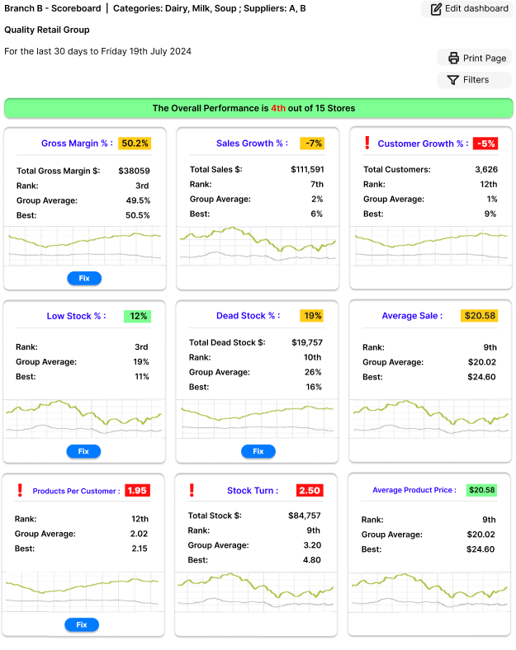

**Scoreboard - Opened filter section (ver. 2)**

**Scoreboard - editing dashboard (draggable KPI cards) (ver. 2)**

